

RECRUITMENT CTF

CHallenge Name : Vingen thinks of FOOD

Dev : Ananya bisht

CatEgOry : Steganogrphy

level : medium

[](http://www.vishwactf.com)[](http://www.viit.ac.in/)

[](https://www.instagram.com/cybercell_viit/)[](https://discord.gg/CcsHSRDapm)[](https://in.linkedin.com/company/cybercell-viit)[](https://github.com/orgs/CybercellVIIT/)[](mailto:cybercell@viit.ac.in)[](http://vishwactf.com)

**2024**

[](https://www.instagram.com/cybercell_viit/)[](https://discord.gg/CcsHSRDapm)[](https://in.linkedin.com/company/cybercell-viit)[](https://github.com/orgs/CybercellVIIT/)[](mailto:cybercell@viit.ac.in)[](http://vishwactf.com)

DEV : [ ] 1

**Question Description:**

**VINGEN an American stout lad, was food addict who loved making acronyms. His regular junk intake mainly consisted of Gatorade, Oreos, Reese’s, Vermicelli, Brownies, Yogurts and Ice-cream…. But today he thinks of something different something healthy….** **SlhtuianlsvCTM{I3_am!pk$_0f_Z@m@k$}**

**What could that be?**

**Given-->**

**Image**

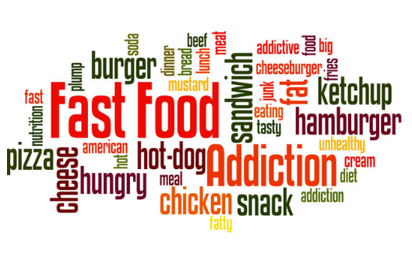

**Solution:**

**Step 1:**

**After reading the question well, you will realize the few given hints-**

**1.“VINGEN” = VINGENERE CIPHER**

**2.Making Acronyms from the food name order we find – GORVBYI**

**3.Given gibberish flag - SlhtuianlsvCTM{I3_am!pk$_0f_Z@m@k$}**

**From here we realize that we need a key to convert this gibberish cipher into a readable one.**

**Step 2:**

**Now this is a Steg question, we will use the given image to extract another hidden image from any site like this---**

<https://incoherency.co.uk/image-steganography/#unhide>

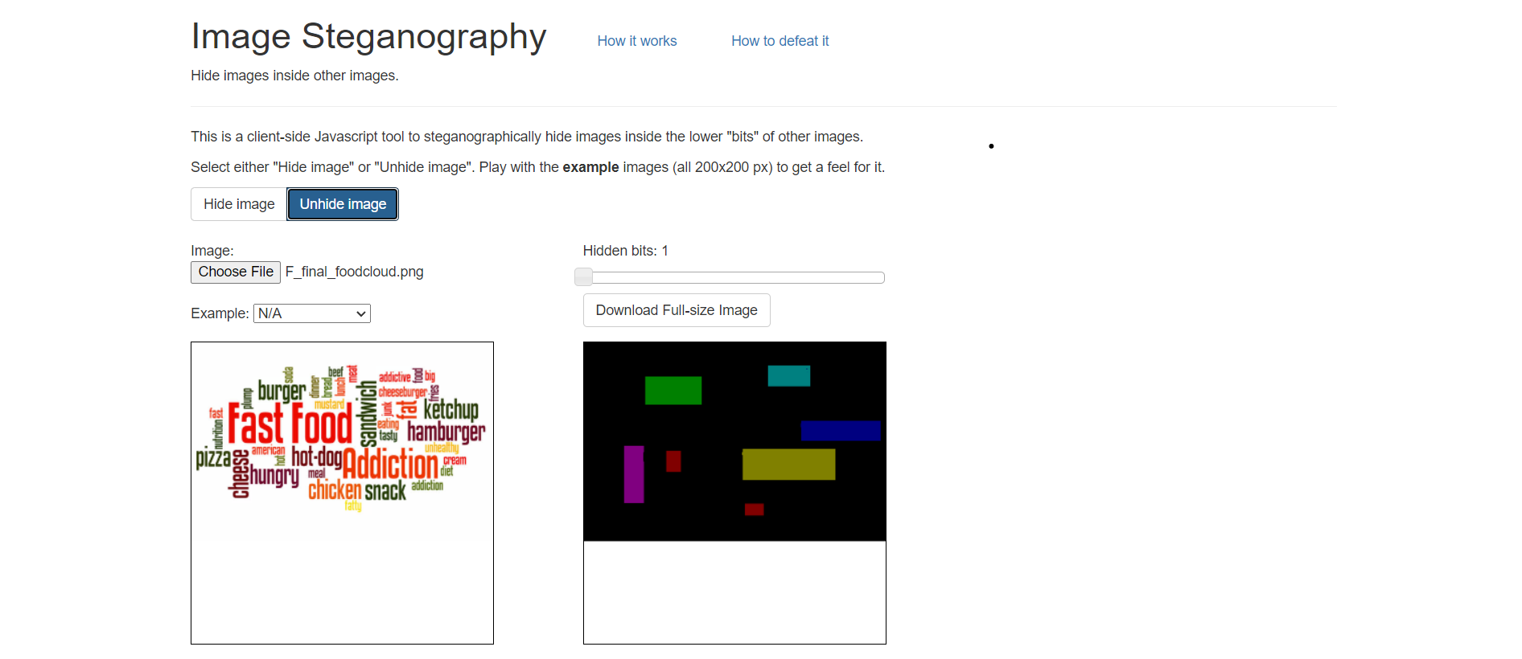

**Step 3:**

**So, on comparing these images, we find that the strips of colours correspond to specific words in the given image, combine this knowledge with hint from “step 1 point 2”**

**Now follow the order of words with respect to the colour of strips from the first acronym we made i.e.---**

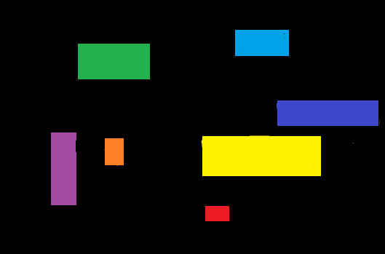

**GORVBYI order 🡪**

**Green = burger = b**

**Orange = hot = h**

**Red = fatty = f**

**Violet = cheese = c**

**Blue = addictive = a**

**Yellow = addiction = a**

**Indigo = hamburger = h**

**:. The order of words is ---- bhfcaah**

**Step 4:**

**Now use this key for the Vigenère cipher on any site like –**

<https://cryptii.com/pipes/vigenere-cipher>

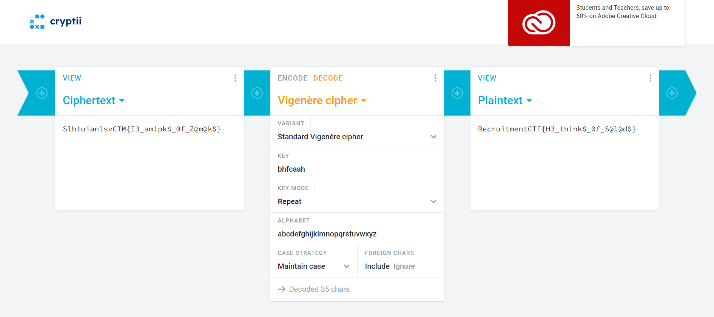

**Input = SlhtuianlsvCTM{I3_am!pk$_0f_Z@m@k$}**

**Found key = bhfcaah**

**Output = RecruitmentCTF{H3_th!nk$_0f_S@l@d$}**

**Enter this flag on the platform and get your points!**